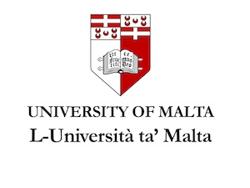
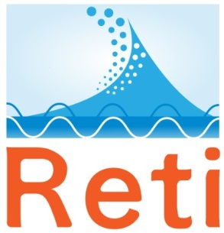
Island Tourism: Economic and Labour Market Implications
Symposium and School organised by the
Centre for Labour Studies
and the
Institute for Tourism, Travel and Culture
University of Malta, Malta
in collaboration with
RETI – the Network of Island Universities
November 18 and 19 (Symposium) and November 21-23 (School)
Venue: Valletta Campus of the University of Malta, St Paul Street, Valletta
PROGRAMME
Friday, 18 November
09.30 Registration and Refreshments
10.00 Opening and Welcome Remarks
10.15 Island Tourism: An Island Perspective – Godfrey Baldacchino, University of Malta / RETI
Discussion
11.00 The Possible Impact of Brexit on Island Country Tourism – Mary L. Tanke & Terry Lease, Florida International University, USA
Discussion
11.45 Island resilience, precarious work and underemployment: insights from Greek regions during recession – Konstantinos Gourzis, Stergios Seretis &
Stelios Gialis, University of the Aegean, Greece

Discussion

12.30 Lunch Break

14.00 Panel Session 1: Corsica

What does Mass Tourism mean? Lessons from some Mediterranean islands - Sauveur Giannoni, University of Corsica, France
The socio-economic impacts of seasonality in Corsica - Justine Muzy, Justine Sustranck, Laura Czarnecki and Bruna Laurant, University of Corsica, France
Discussion
15.15 Refreshment Break
15.30 Panel Session 2: Dutch Caribbean

The Politics of Island Tourism in the Dutch Caribbean “municipalities’ – Wouter Veenendaal, University of Leiden, The Netherlands

Labour Market Dimensions of SITEs: Developments in the Caribbean cases of Aruba and Sint Maarten – Arjen Alberts, University of Amsterdam, The Netherlands (based on Sint Maarten)

16.45 End of Symposium Day 1

Dinner in Valletta

Saturday, 19 November
09.15 Refreshments and Registration
09.30 Panel Session 3 – Malta and the ‘Sicilian Archipelago’
Challenges of Coastal & Marine Eco-Tourism in small central Mediterranean Islands – Karl Agius, University of Malta, Malta
Return to Base: Expatriates as Tourists revisiting their former island home – Marie Avellino Stewart & George Cassar, University of Malta, Malta
Intercultural Competence for Labour Markets in Small Island Tourism: Focus on Malta – Simon Caruana, University of Malta, Malta
Discussion
11.30 End of Symposium Day 2
Lunch in Valletta – Free Afternoon / Evening
Sunday 20 November
All Day Field-trip / Study Visit (Weather Permitting) - Programme to be announced
Monday 21 November
09.15 Registration and Refreshments
09.30 Welcome Remarks
School Block 1:
Island Studies: New Horizons? New Possibilities?
Open Panel Discussion – Godfrey Baldacchino (Malta), Per Lind (Sweden) and other scholars.
Discussion
12.00 Lunch Break
1.30 School Block 2:
Community Tourism and Sustainability – Giuseppina Cardia and colleagues, University of Malta, Malta
Discussion
4.00 End of School Day 1

Tuesday 22 November
09.15 Registration and Refreshments
09.30 School Block 3:
Deterritorialisation and Non-Sovereign Futures: Migration and Tourism in Small Island Jurisdictions – Jack Corbett, University of Southampton, UK and Wouter Veenendaal, University of Leiden, The Netherlands
Discussion
12.00 Lunch Break
1.30 School Block 4:
Victims of their own success: Aruba and Sint Maarten negotiating limits to small island tourism development – Arjen Alberts, University of Amsterdam, The Netherlands (based on Sint Maarten)
Discussion
4.00 End of School Day 2

